Diodes
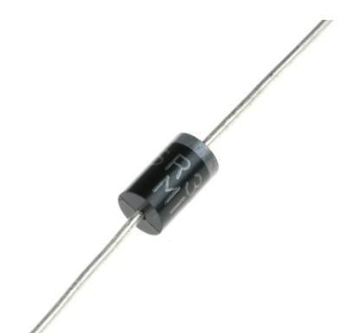

ME
velocity ME
qpp Hp diffusion Mp
conductivity que res PT
donor imp density am E
ND at
1
Dr. Munirah Boufarsan and Eng. Ahmed Haytham

Introduction to Diodes
• The simplest and most fundamental nonlinear circuit element is the
diode .
• The diode has two terminals (Anode + terminal, Cathode – terminal)
• The diode has a nonlinear i – v characteristic.
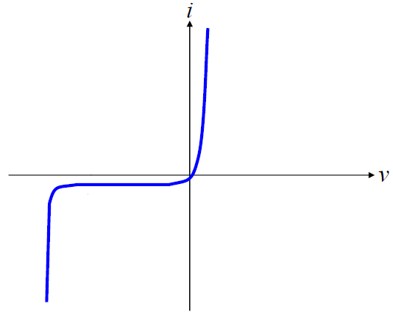

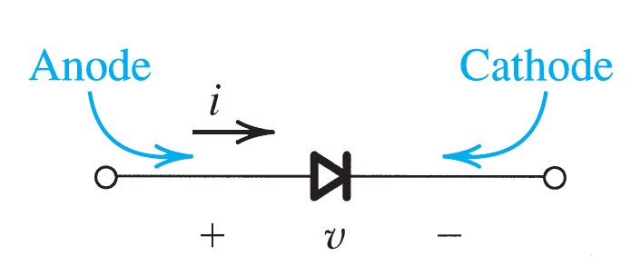

2
Dr. Munirah Boufarsan and Eng. Ahmed Haytham

Ideal Diode
• The ideal diode has the following i-v characteristics • If a negative voltage v is applied to the
diode, no current flows and the diode behaves as an open circuit and it is said to be reverse biased with a zero current
and is said to be off . • On the other hand, if a positive current is applied to the ideal diode, zero
voltage drop appears across the diode and works as a short circuit in the forward biased . Diode is said to be on .
ideal no lose
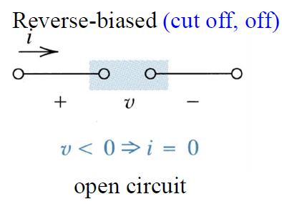

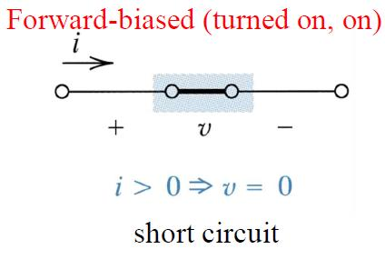

3
Dr. Munirah Boufarsan and Eng. Ahmed Haytham

Ideal Diode
• The forward current through a conducting diode & the
reverse voltage across a cutoff diode are determined by an external circuit
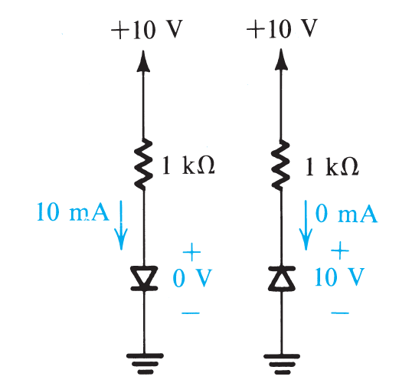

forward biased
reverse biased
4
Dr. Munirah Boufarsan and Eng. Ahmed Haytham

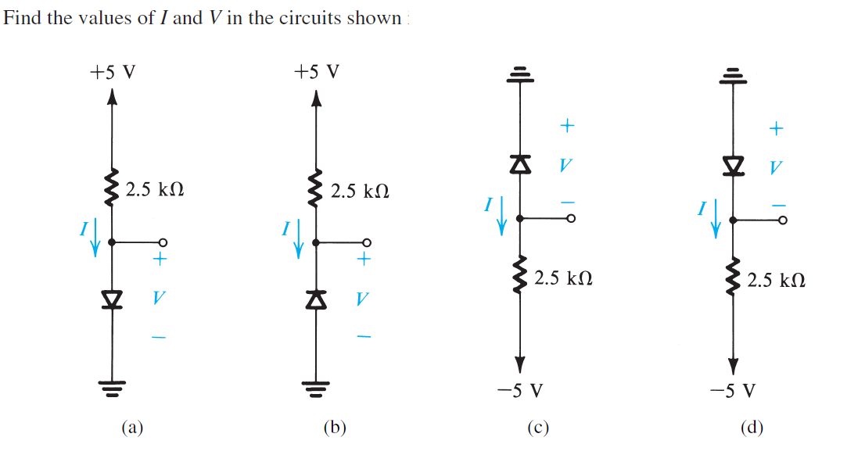

Example 1
we
assume
ON
s assume off off red
7 sk 5 Ivesu v 2.5
254 0 I
1 Is t.su
lives
2 2nA Is 2mA
1 5
5
Dr. Munirah Boufarsan and Eng. Ahmed Haytham

Example 1
6
Dr. Munirah Boufarsan and Eng. Ahmed Haytham

Example 1
7
Dr. Munirah Boufarsan and Eng. Ahmed Haytham

Example 1
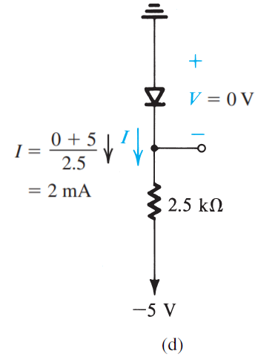

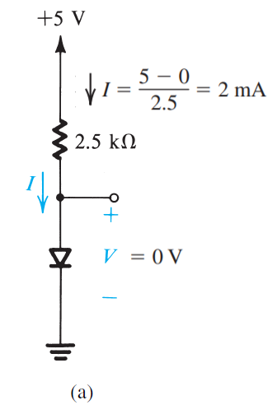

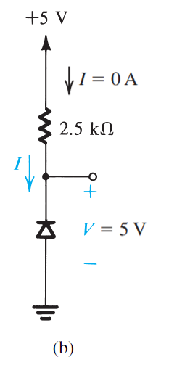

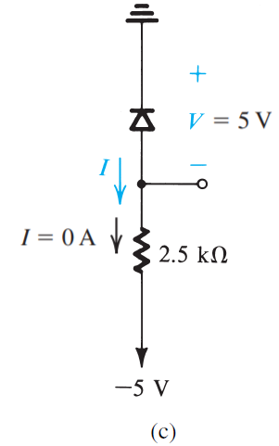

8
Dr. Munirah Boufarsan and Eng. Ahmed Haytham

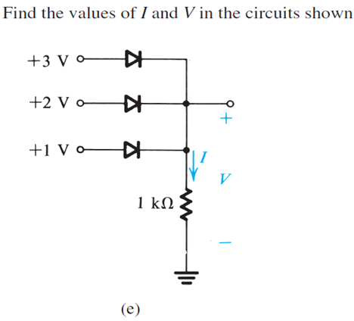

Example 2
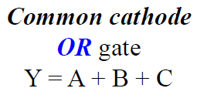

c
pallel diodes we'll have an output if at least one is on cathodes
tonnected with output
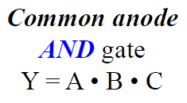

9
Dr. Munirah Boufarsan and Eng. Ahmed Haytham

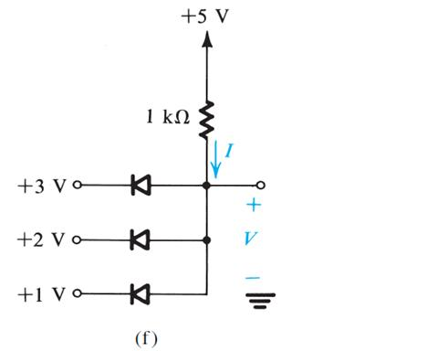

Example 2

Joe
all week to work together
andwe'll take the value
10
Dr. Munirah Boufarsan and Eng. Ahmed Haytham

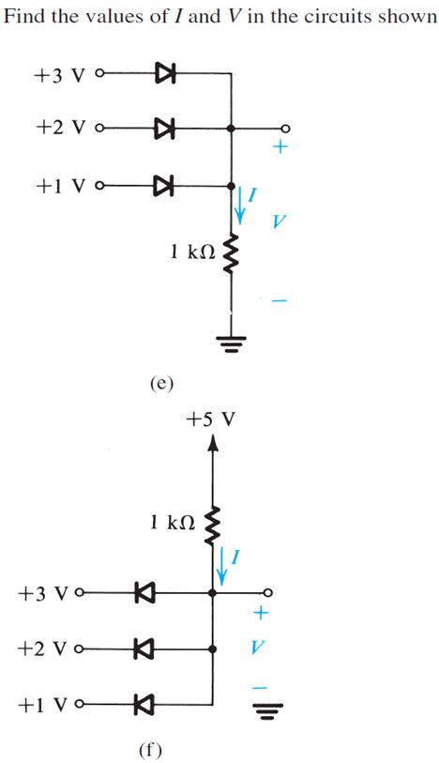

Example 2
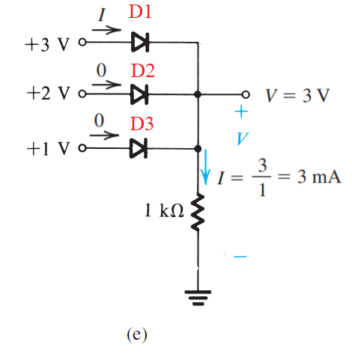

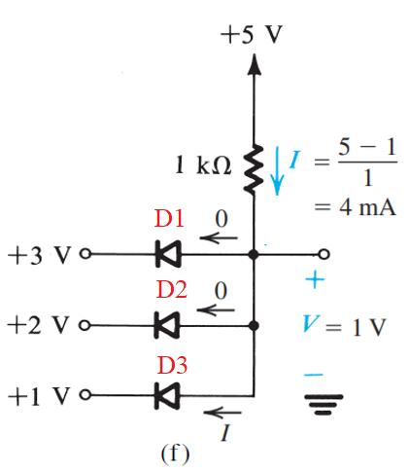

11
Dr. Munirah Boufarsan and Eng. Ahmed Haytham

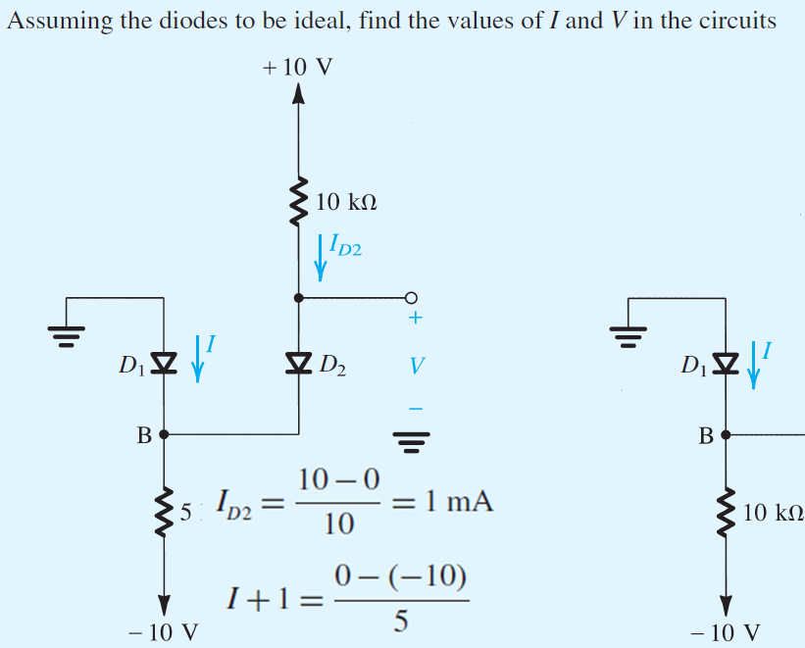

Example 2
1mA
Assume D1 and D2 are on
I 0 511 It In Ix K
2mA
I mA
12
Dr. Munirah Boufarsan and Eng. Ahmed Haytham

assume P D ON
Example 2
Assume D1 and D2 are on
Ip 2mA
R Ix 1,1 1mA
Ix It A
p is off wrong last 13.3 10
13
Dr. Munirah Boufarsan and Eng. Ahmed Haytham

Terminal Characteristics of Junction Diodes
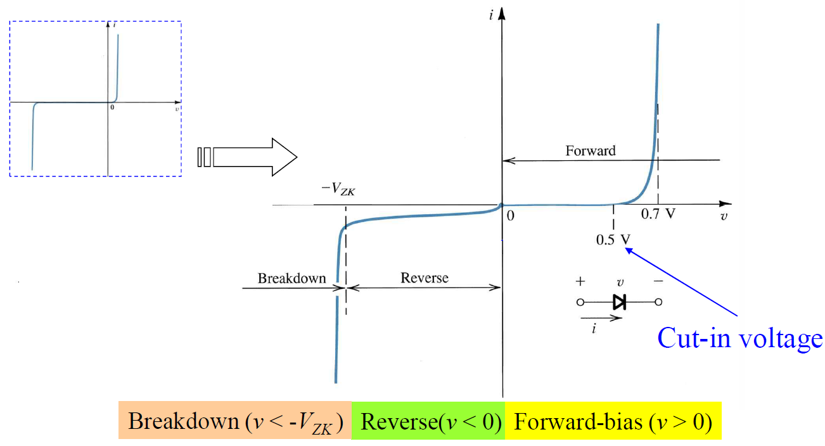

not ideal
3regions
Formoed drop voltage or threshold voltage
14
Dr. Munirah Boufarsan and Eng. Ahmed Haytham

Terminal Characteristics of Junction Diodes
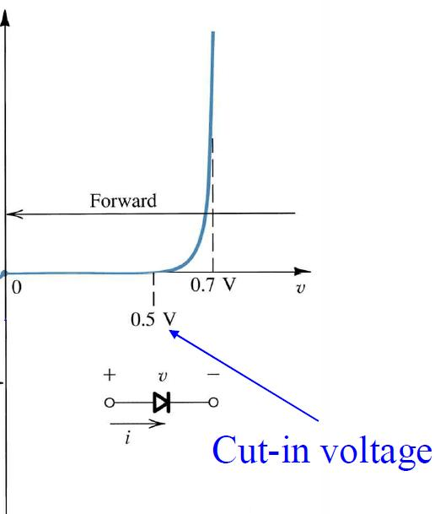

Forward Bais: • When the voltage increases a little, there is almost no current. But at cut-in volage, the current starts to follow.
• After a certain point (called threshold voltage, around 0.7 for silicon), the diode suddenly allows a large current to pass.
Formoed drop voltage or threshold voltage
• The graph rises sharply upward on the right side after this voltage
Why? The applied voltage close or grater than build in voltage Vo
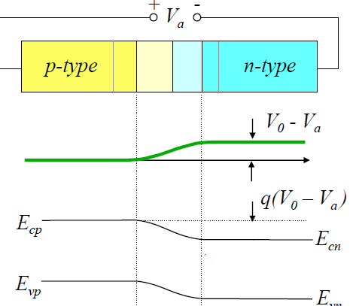

TCM 2T1 th 471
T 1 I opalogy using subs
15 Dr. Munirah Boufarsan and Eng. Ahmed Haytham

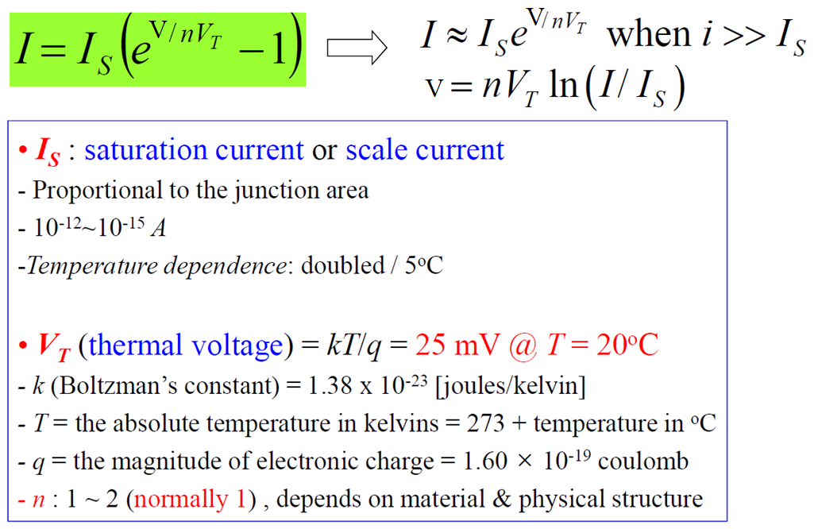

16
Dr. Munirah Boufarsan and Eng. Ahmed Haytham

The Forward-Bias Region
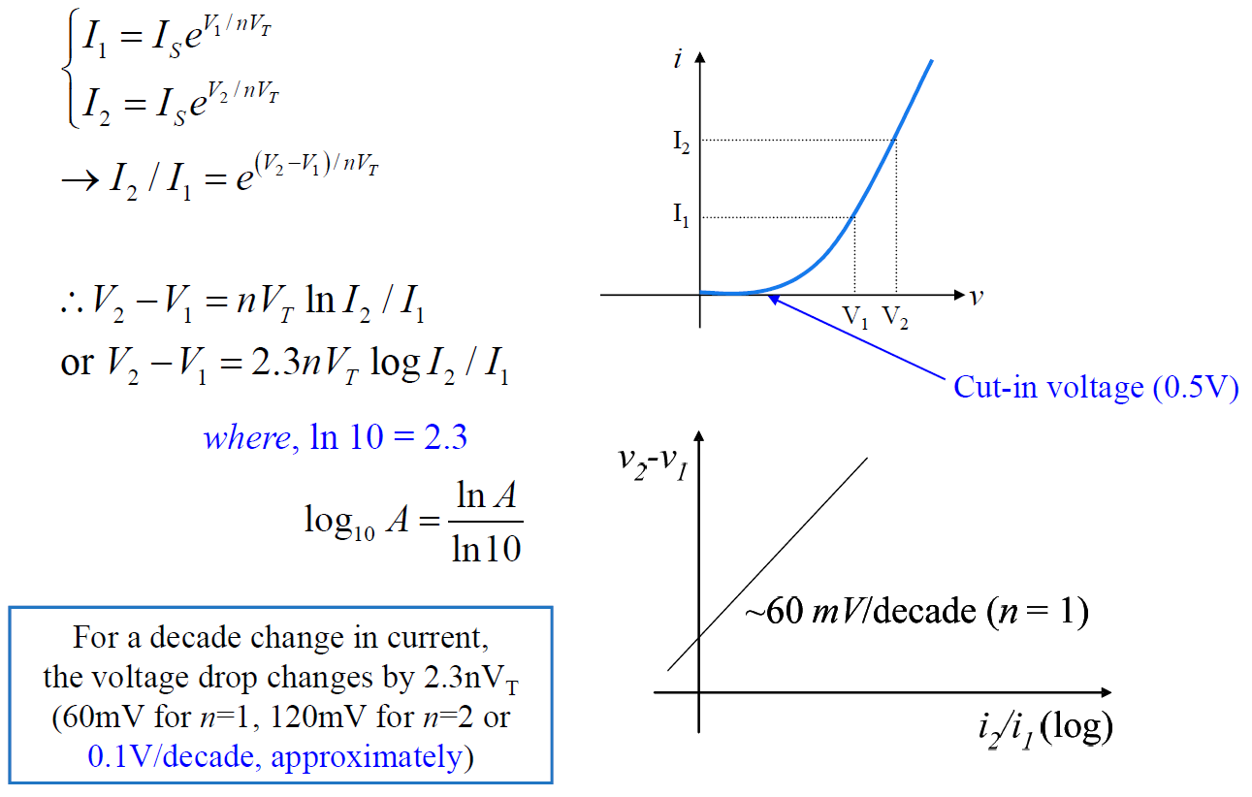

higher temp
faster
growth in cut in less than 05
ii it we
17
Dr. Munirah Boufarsan and Eng. Ahmed Haytham

The Forward-Bias Region
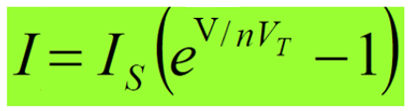

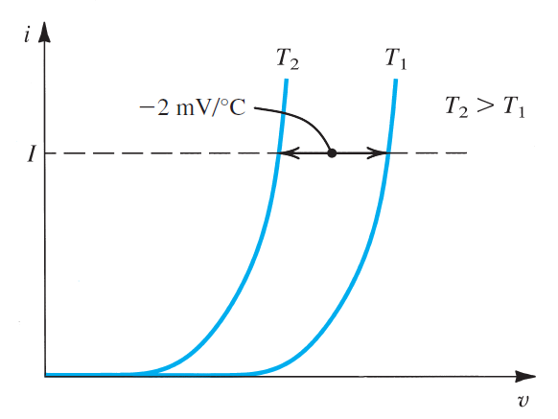

Since both I S and V T are functions of temperature, the forward i – v characteristic varies with temperature, as illustrated in Fig.
At a constant current, the voltage drop decreases by approximately 2 mV for every 1°C increase in temperature.
18
Dr. Munirah Boufarsan and Eng. Ahmed Haytham

Example 3
with room temp
Lease

I Is I e mVt
Up nV lu It 1
Is 0.1 10 15
Ip 300
assume n l if not given up 25 10 en It O 718N
Is 10 10 s
Vp 25 10 3 In It 0.6030
I 0.18A I 1mA Up 0.7450
19
Dr. Munirah Boufarsan and Eng. Ahmed Haytham

Example 4

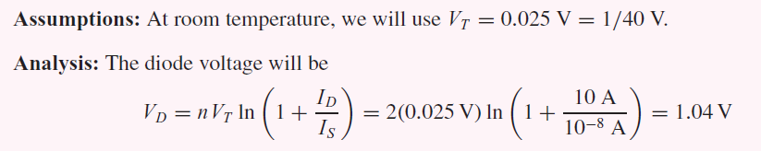

20
Dr. Munirah Boufarsan and Eng. Ahmed Haytham

Example 5

21
Dr. Munirah Boufarsan and Eng. Ahmed Haytham

Reverse-Bias and Breakdown Regions
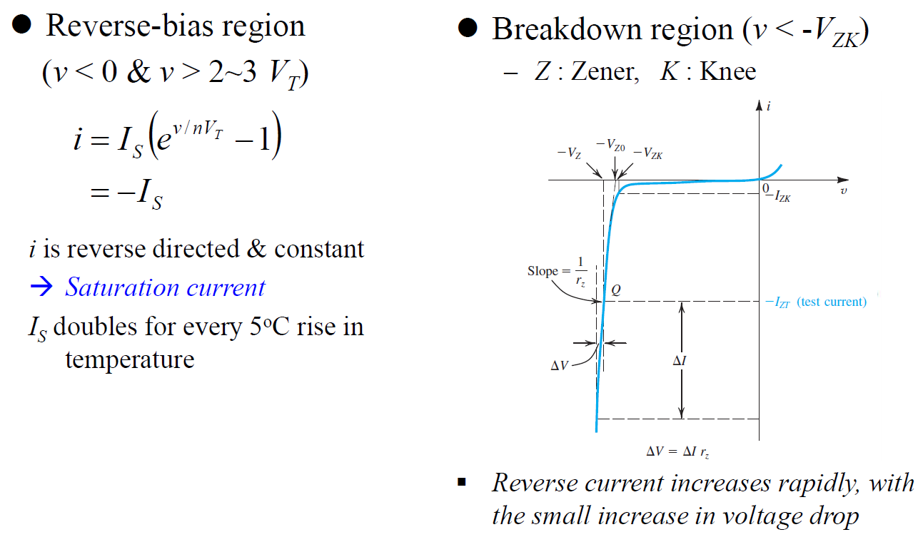

22
Dr. Munirah Boufarsan and Eng. Ahmed Haytham

Today we'll talk abt Zener
why is it called Zener I V1 Ver
Because it'll work in reverse breakdown Needs to be larger in my to work

Modeling the Diode Forward Characteristic
1- Simpler model for diode forward characteristics is a forward-conducting diode exhibits a constant voltage drop V D (=0.7V).
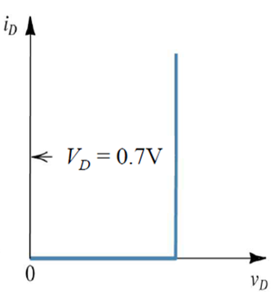

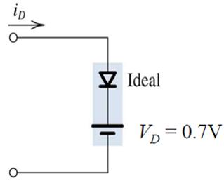

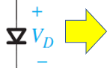

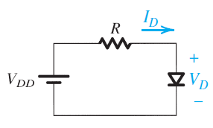

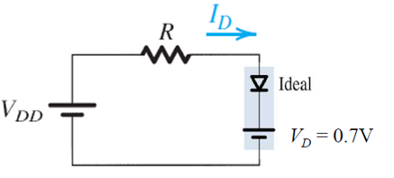

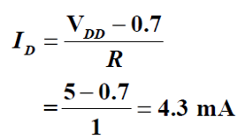

23
Dr. Munirah Boufarsan and Eng. Ahmed Haytham

Example 6
Determine the current I in the circuit shown
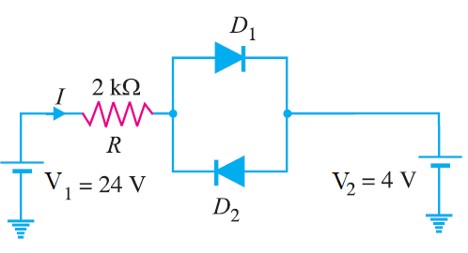

Suggest that diode D 1 is forward biased and diode D 2 is reverse biased
24
Dr. Munirah Boufarsan and Eng. Ahmed Haytham

Example 7
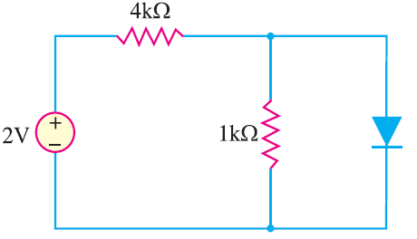

Determine the state of diode f or the circuit shown, find I D and V D .
Solution. Let us assume that the diode is ON
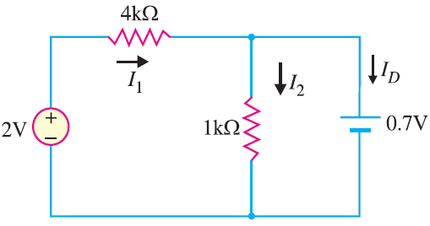

25
Dr. Munirah Boufarsan and Eng. Ahmed Haytham

Example 7 Continue
Since the diode current is negative, the diode must be OFF and the true value of diode current is I D = 0 mA .
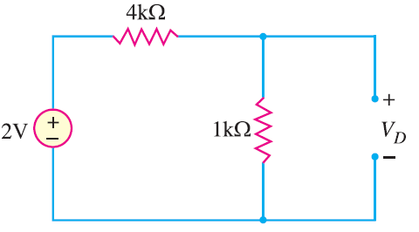

We know that 0.7V is required to turn ON the diode. Since V D is only 0.4V, the answer confirms that the diode is OFF .
26
Dr. Munirah Boufarsan and Eng. Ahmed Haytham

Example 8
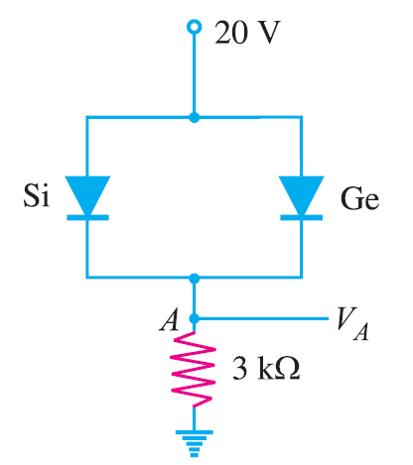

Find the voltage V A in the circuit shown.
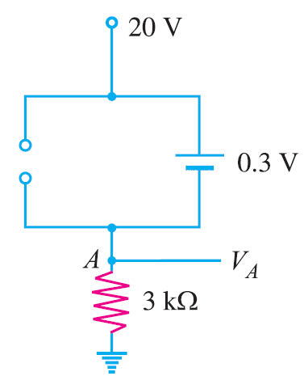

27
Dr. Munirah Boufarsan and Eng. Ahmed Haytham

Example 9
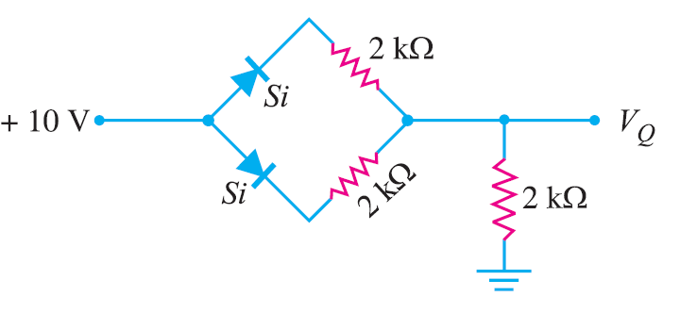

Find V Q and I D in the network shown
Applying Kirchhoff’s voltage law to the closed circuit ABCDA , we have,
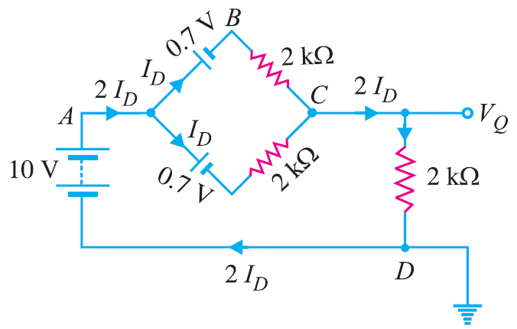

28
Dr. Munirah Boufarsan and Eng. Ahmed Haytham

Example 10
Determine the currents I 1 , I 2 and I 3 for the network shown
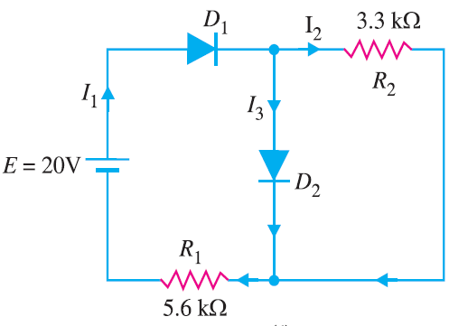

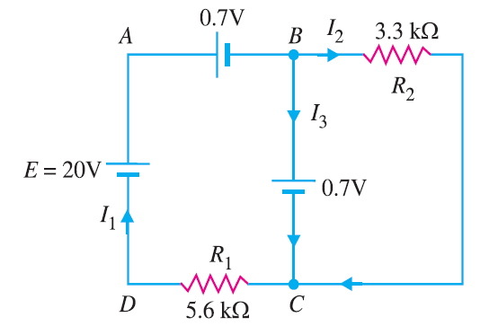

29
Dr. Munirah Boufarsan and Eng. Ahmed Haytham

Modeling the Diode Forward Characteristic
2- More exact and approximate model for diode forward characteristics is a forward-conducting diode exhibits a constant voltage drop V D (=0.7V) with a series Forward resistance, r D = (10-60)Ω.
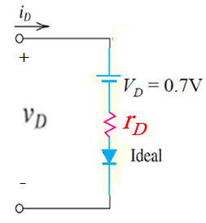

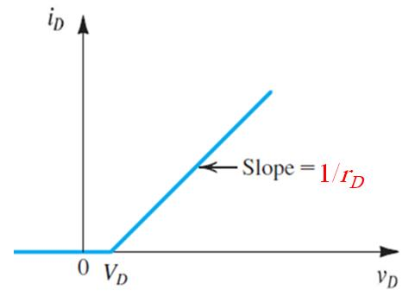

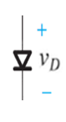



30
Dr. Munirah Boufarsan and Eng. Ahmed Haytham

Diode Small-Signal Model
Application, where a small ac signal is superimposed on the dc quantities
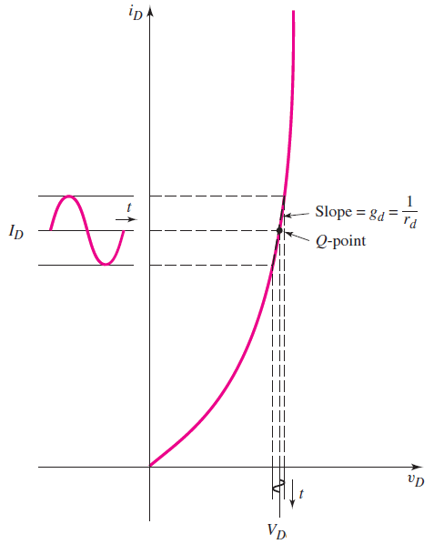

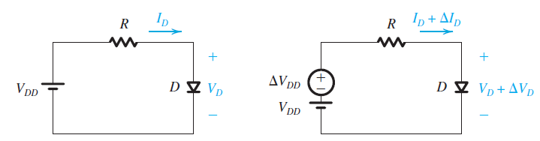

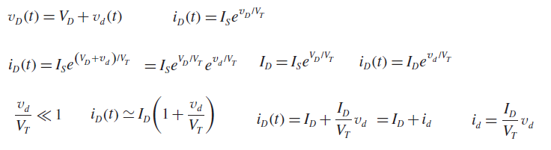

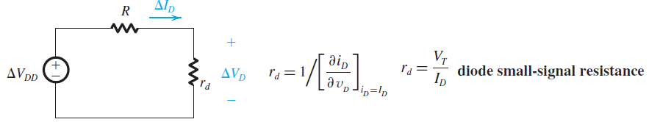

frTmDcanatysis
31
Dr. Munirah Boufarsan and Eng. Ahmed Haytham

Example 11
Assume circuit and diode parameters of VPS = 5 V, R = 5 k, V D = 0 . 6 V, and v i = 0 . 1 sin ωt (V). Determine and
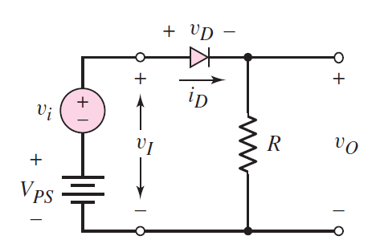

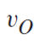

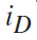

6 0 88mA
Vo IDQ R 4 41
r 0 86 0.0 295k 2 no 4.44 DC
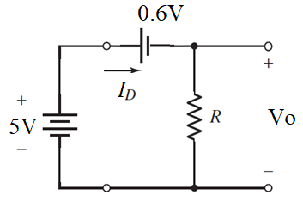

0.995 sinwt
AC in 888 19.9sinut
ia ten iga
19.9 sinite ma ne
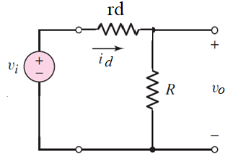

Vo id R 0.0995 sin wt
32
Dr. Munirah Boufarsan and Eng. Ahmed Haytham

Operation in the Reverse Breakdown Region
Zener Diodes
ON when V17 Vert
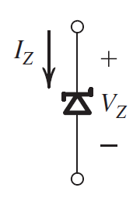

Very steep i-v curve in the breakdown region - Almost constant voltage drop regardless of load current & power supply ripple - Breakdown diode, Zener diode : operation in the breakdown region
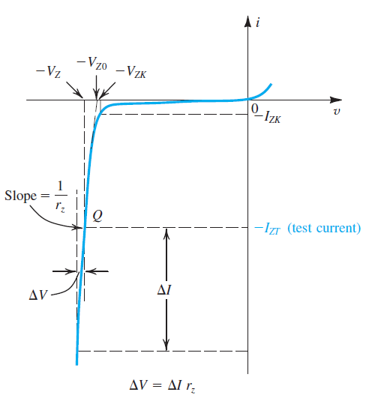

Zener diodes are fabricated with voltages V Z in the range of a few volts to a few hundred volts. In addition to specifying V Z (at a particular current I ZT ), r z , and I ZK , the manufacturer also specifies the maximum power that the device can safely dissipate
work afterBD
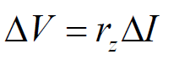

33
Dr. Munirah Boufarsan and Eng. Ahmed Haytham

Operation in the Reverse Breakdown Region
Zener Diodes
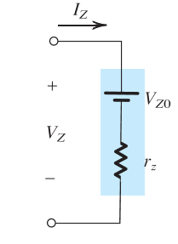

shunt regulator
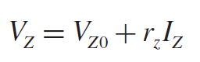

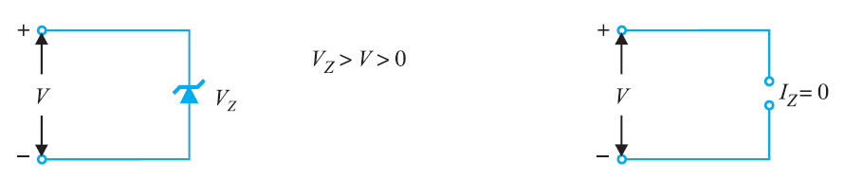

34
Dr. Munirah Boufarsan and Eng. Ahmed Haytham

Solving Zener Diode Circuits
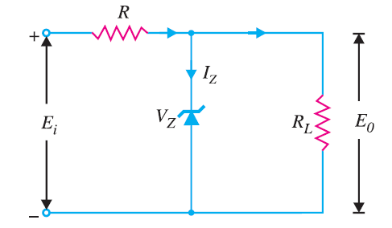

1- E i and R L are fixed.
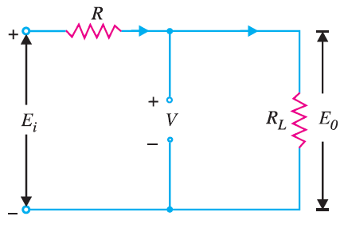

First Calculate:
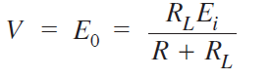

35
Dr. Munirah Boufarsan and Eng. Ahmed Haytham

Use of Zener Diode as Shunt Regulator
Then:
- If V≥V Z , the Zener diode is in the “on” state and its equivalent model
can be substituted as
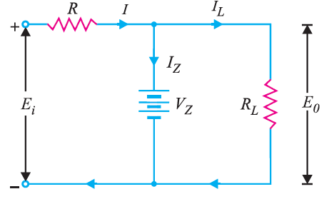

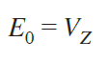

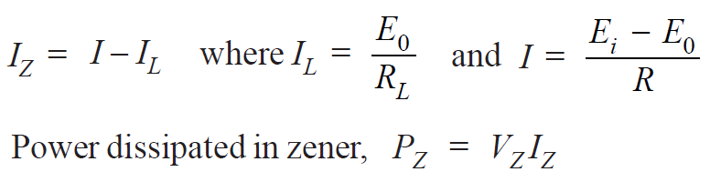

36
Dr. Munirah Boufarsan and Eng. Ahmed Haytham

Use of Zener Diode as Shunt Regulator
- If V < V Z , the diode is in the “off” state as
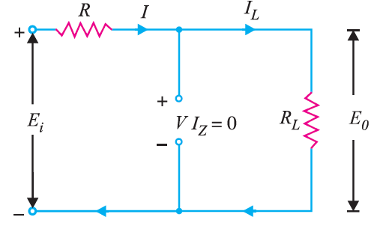

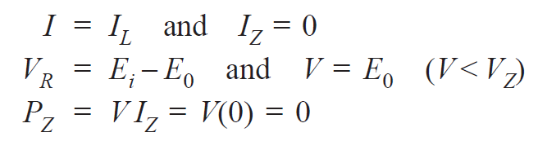

37
Dr. Munirah Boufarsan and Eng. Ahmed Haytham

Use of Zener Diode as Shunt Regulator
2- E i is fixed and R L is varying.
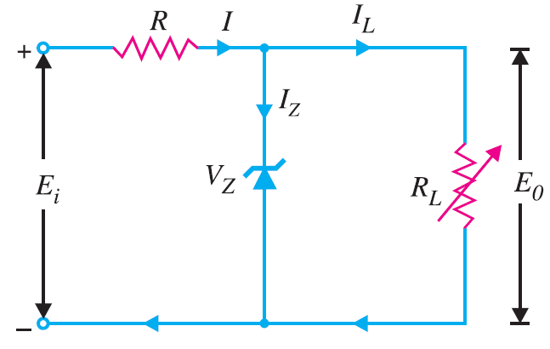

(i) R Lmin and I Lmax .
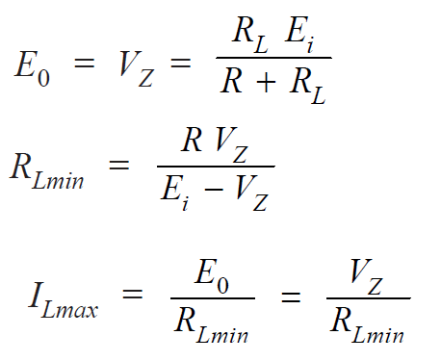

38
Dr. Munirah Boufarsan and Eng. Ahmed Haytham

Use of Zener Diode as Shunt Regulator
2- E i is fixed and R L is varying.

(i) I Lmin and R Lmax .
If the maximum current that a Zener can carry safely is I ZM ,

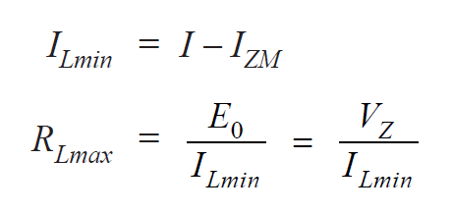

Dr. Munirah Boufarsan and Eng. Ahmed Haytham 0
39

Use of Zener Diode as Shunt Regulator
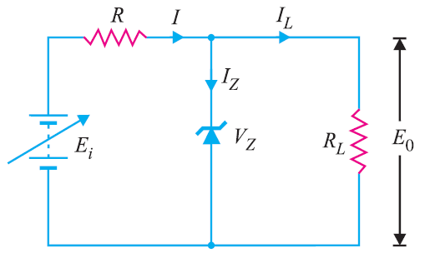

3- Variable E i and fixed R L
V on zener
UDR
40
Dr. Munirah Boufarsan and Eng. Ahmed Haytham

Use of Zener Diode as Shunt Regulator

3- Variable E i and fixed R L
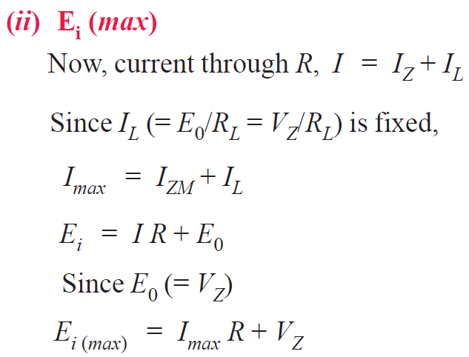

when zener is on the
current thro is max current
41
Dr. Munirah Boufarsan and Eng. Ahmed Haytham

zener
8 1ss
Example 12
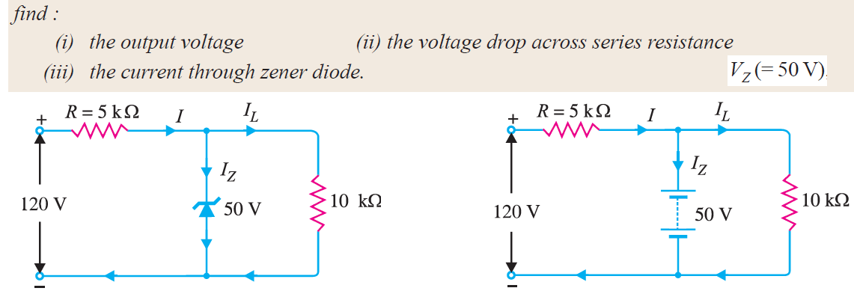

Ux
v of
80 ad They call
it Regulato
cause it regu i Vo 50 V es voltage
ii Ux he 50 700 I Isp 70g 14mA
iii 12 I I L m 5ms 9mA I 2 5 5m A
42
Dr. Munirah Boufarsan and Eng. Ahmed Haytham

Example 13
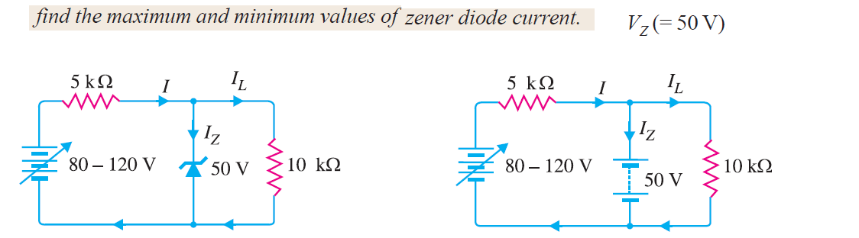

impygotes
Von zeker is 50 but current
I zmex Ei mix 1200 I 5 5 mA V1 I on load charged Iza Imai I Ima Éigff 14mA No current is constant what do we know abt
Izmex 9mA I 2min Iain Ic 805 5mA zeker
6 5 1mA evenwhen we
changed the inpt the output load
43
Dr. Munirah Boufarsan and Eng. Ahmed Haytham

the output on load didn't change Load getsthe same out
Example 14
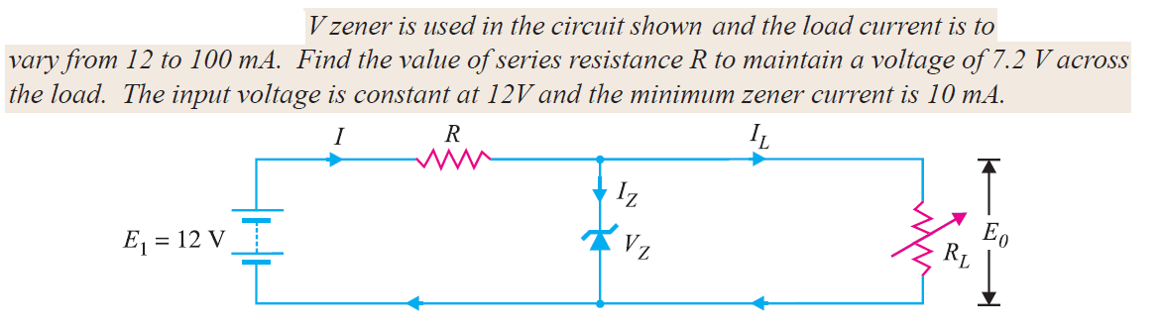

4 8
7 2
V2 7.2 I me
I_In I at min
R 5 I Iz I low loom 10mA
43.5 2 what we do
4
zever has a limit is we check
on of the edg for then the other and if it's on iffthermidd
44
Dr. Munirah Boufarsan and Eng. Ahmed Haytham

is ON
Example 15
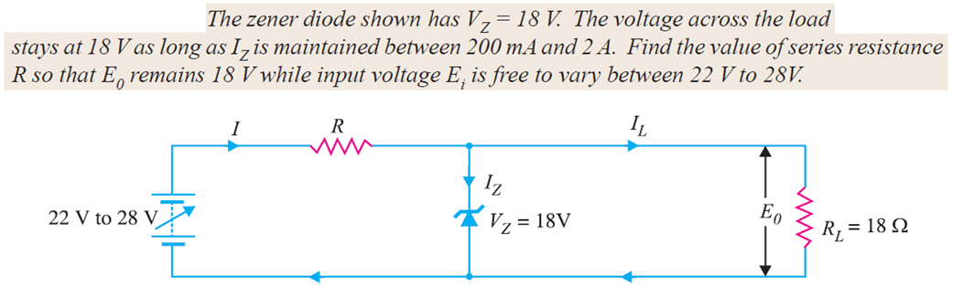

t
f
circuit is the
same the
regulator regulator Ic 1mA what we 1am charge
is the input R Ei 22,5 3.33 2
or output
I
Fagging 200m 1 1200mA
Einin
1 3.33 I 3A 12 3 1 2A
45
Dr. Munirah Boufarsan and Eng. Ahmed Haytham

Example 16
Hw
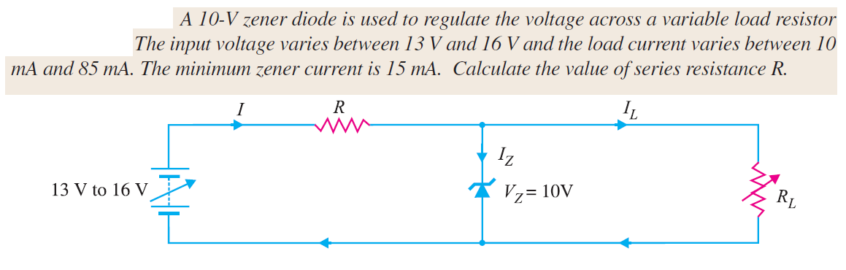

70 85
Ei 13 16 Yifut 13 10
12 10 85 Rs É Igt 100mA
Iii's
46
Dr. Munirah Boufarsan and Eng. Ahmed Haytham
16 and

E.at in.EsusTttei
Example 17
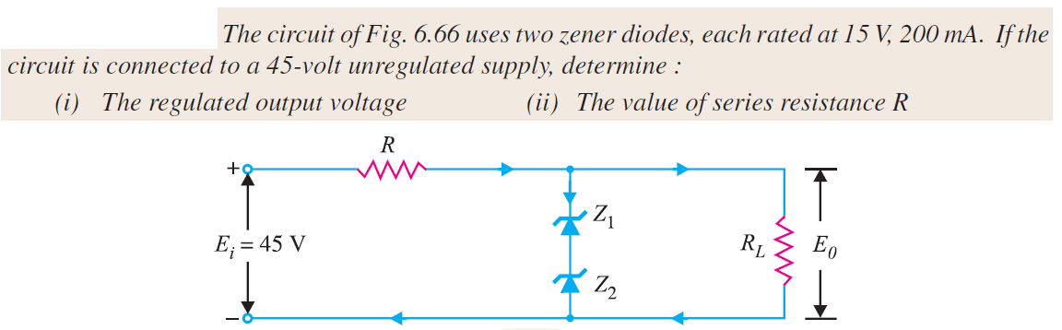

In exam
may notb
f given the circuit
maybe asker about a Regulator regulator
Eo 15 15 30 ever ON 12 2mA FYE
Un 150 R is 7s Imax 12 200
c worst case R will always
have 200m to diathe
but 9
47
Dr. Munirah Boufarsan and Eng. Ahmed Haytham

Example 17
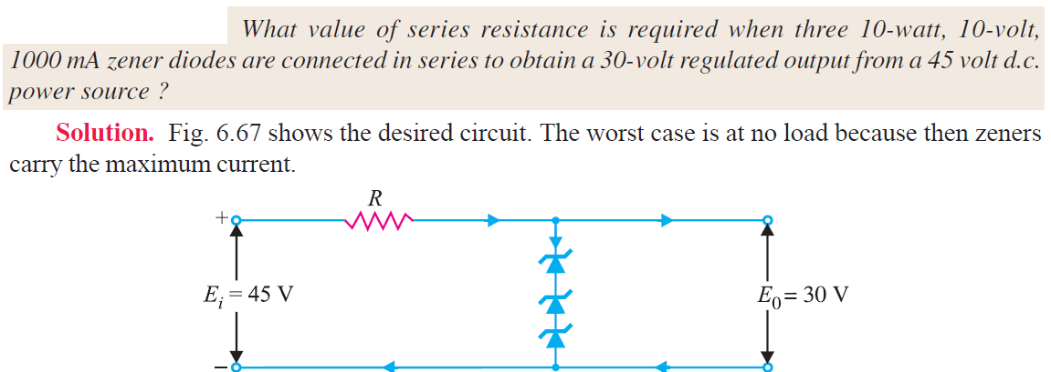

we put 3
Zehers her
so V30 how my
here design is
on max curr
min R
48
Dr. Munirah Boufarsan and Eng. Ahmed Haytham

Example 18
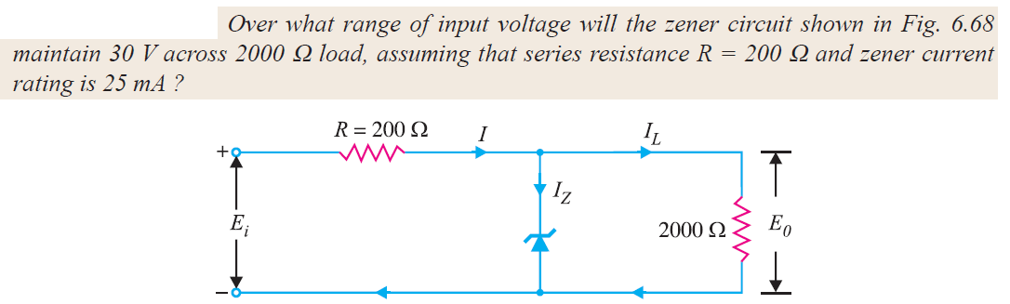

so
min V max V Vo 301 12
0
Re 2000 Rs 700 12 1 I I 112
75 25
I2
max 30 3 0200 30 IR
30 IR IRS
49
Dr. Munirah Boufarsan and Eng. Ahmed Haytham

Example 19
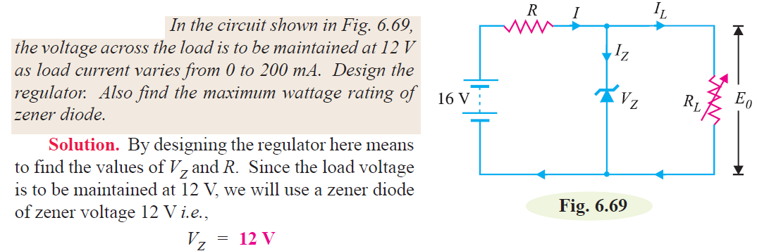

50
Dr. Munirah Boufarsan and Eng. Ahmed Haytham

long very imp for
Example 20
exam
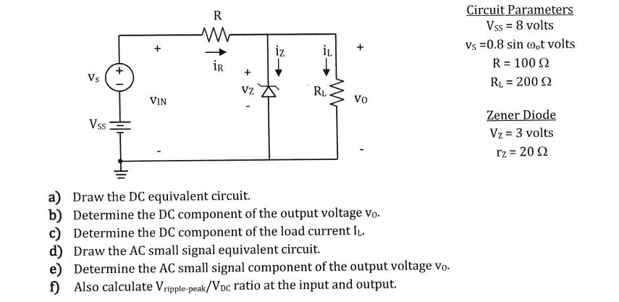

51
Dr. Munirah Boufarsan and Eng. Ahmed Haytham

